git init

echo "# desafiotype" >> README.md

git add README.md

git commit -m "first commit"

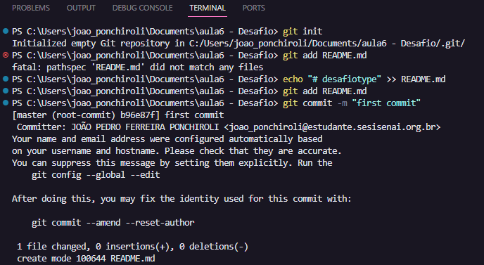

git remote add originhttps://github.com/JPonchiroli/DesafioType

git push -u origin main

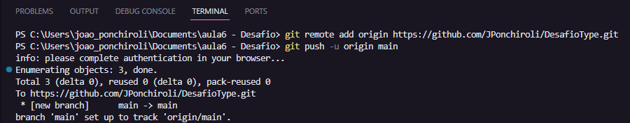

git add .

git commit -m “Commit do Desafio”

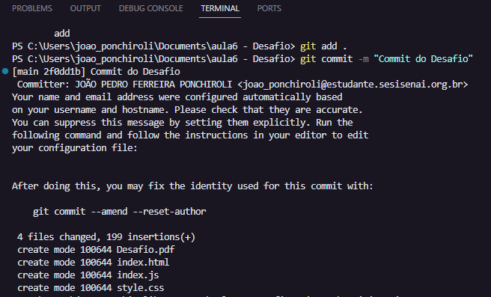

git push origin main

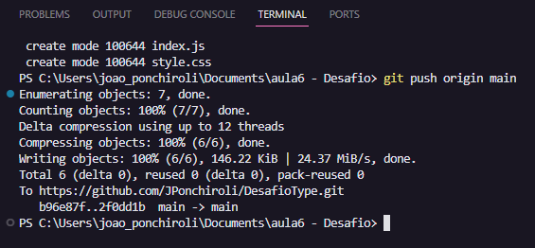

Repositório GitHub - <https://github.com/JPonchiroli/DesafioType>

